**TFT(Thin-Film-Translator) Display with Arduino**

**Description**: In this project, we will show how TFT display works and text show in the TFT display.

**Hardware Requirement:**

* Arduino board
* TFT display-8pin[LED,SCK,SDK,A0,RESET,CS,GND,VCC]
* Jumper wire
* Breadboard
* USB cable

**TFT display and it’s Connection**:

TFT Display:

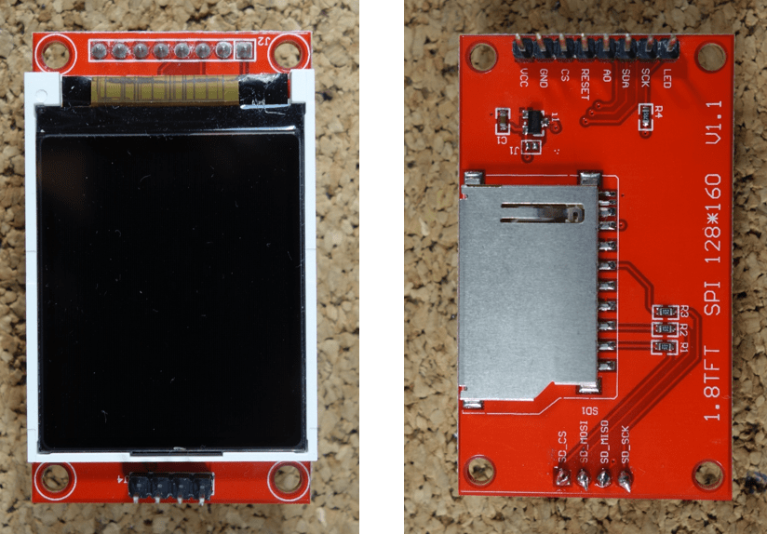

**Connection:**

|  |  |
| --- | --- |
| **1.8 TFT Display** | **Wiring to Arduino Uno** |
| LED | 3.3 V |
| SCK | 13 |
| SDA | 11 |
| A0 or DC | 9 |
| RESET | 8 |
| CS | 10 |
| GND | GND |
| VCC | 5 V |

Code:

|  |
| --- |
| #include<TFT.h>  #include<SPI.h>  #define cs 10  #define dc 9  #define rst 8  // create an instance of the library  TFT tft = TFT(cs, dc, rst);  void setup() {  // put your setup code here, to run once:  tft.begin();  // clear the screen with a black background  tft.background(0, 0, 0);  //set the text size  tft.setTextSize(2);  }  void loop() {  // put your main code here, to run repeatedly:    // set a random font color  tft.stroke(0,255,0);  tft.setCursor(0,40); //tft.setCursor(column, row);  tft.print("Hellow World!");  } |

**Output:**



**Code for the text moving from up to down:**

|  |
| --- |
| #include<TFT.h>  #include<SPI.h>  #define cs 10  #define dc 9  #define rst 8    // create an instance of the library  TFT tft = TFT(cs, dc, rst);  void setup() {  // put your setup code here, to run once:  tft.begin();  // clear the screen with a black background  tft.background(0, 0, 0);  //set the text size  tft.setTextSize(2);  }  void loop() {  // put your main code here, to run repeatedly:    // set a random font color  int i=0;    for(i;i<100;i+=5)  {  tft.background(0,0,0);  tft.stroke(0,250,0);  tft.text("HELLOW",5,i); // (" ",col,row)  delay(100);  };  } |

Link for TFT basic:

<https://create.arduino.cc/projecthub/electropeak/ultimate-beginner-s-guide-to-run-tft-lcd-displays-by-arduino-081006>